**Institute of Technology of Cambodia**

**Department Applied Mathematics and Statistics**

**Assignment 02**

**Subject: Mathematical Modeling**

**Group: AMS-A-10(th) Team**

**Members:**

**KRY SENGHORT e20200706**

**LENG MOURYHONG e20200413**

**LEAT SEANGLONG e20200971**

**LIM SUNHENG e20200807**

**Academic Year: 2022-2023**

***Exercise 01:***

You plan to invest part of your paycheck to finance your children’s education. You want to have enough in the account to draw $1000 a month every month for 8 years beginning 20 years from now. The account pays 0.5% interest each month.

1. How much money will you need 8 years from now to accomplish the financial objective?

Assume you stop investing when your first child begins college—a safe assumption.

1. How much must you deposit each month during the next 20 years?

***Solution:***

1. **Find the money that will need 8 years from now to accomplish the finance objective**

Let  be the change amount of money in account each month

 denote the amount at the end of n-th month

*r* denotes the monthly interest rate

*w* denotes the monthly withdrawal made of $ 1000

*n* denotes the number of months for calculation

Then we have:





The initial capital is to last 96 months.

So, the amount at the end of 96th month should be 0 or 

Consider equation: 

Since *r* = 0.5% = 0.005 , *w* = $1000

We have : 

**Therefore, the initial amount of money that you will need 20 years from now to accomplish the financial objective is $ 76,095**

1. **Find the amount of money that you must deposit each month during the next 20 years:**

**Proof:**

We have:  , Since 20 years = 20 x 12 = 240 months

Then we obtain:



**Therefore, the amount money that you must deposit each month during the next 20 years is $ 210,150.885**

**Graph Representation:**

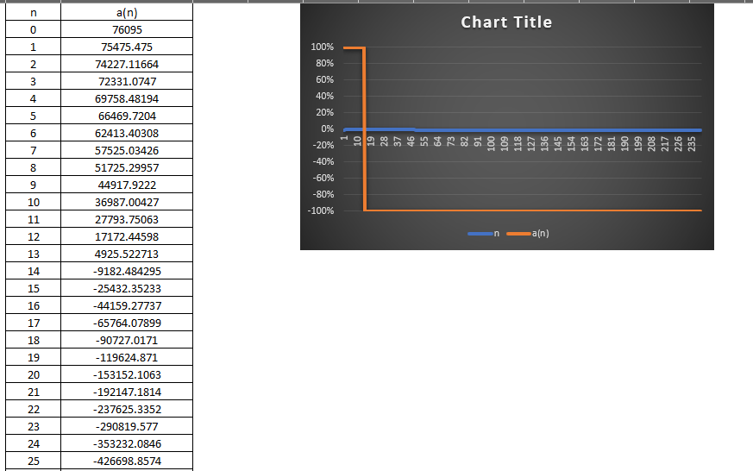

***Exercise 02:***

Assume we are considering the survival of whales and that if the number of whales falls below a minimum survival level m, the species will become extinct. Assume also that the population is limited by the carrying capacity M of the environment. That is, if the whale population is above M, then it will experience a decline because the environment cannot sustain that large a population level. In the following model, an represents the whale population after n years. Build a numerical solution for *M* = 5000, *m* = 100, *k* = 0.0001, and  = 4000. . Now experiment with different values for *M, m*, and *k*. Try several starting values for . What does your model predict?

***Solution:***

Let  be the change number of whales

 be the number of whales at the n-th case

*M*  be the maximum level survival of whale

*m* be the minimum level survival of whale

Consider on the below formula:





Since: *M* = 5000, *m* = 100, *k* = 0.0001, and  = 4000

Then, the dynamical system is written by: $\left\{\begin{aligned}a_{n+1}-a_{n}={10}^{-4}\left(5000-a_{n}\right)\left(a_{n}-100\right) \\ a_{0}=4000\end{aligned}\right.$

Checking several values of experiment:



Based on this model we obtain:



**Therefore, the change number of survival of whale is decrement.**

**The Graph representation:**

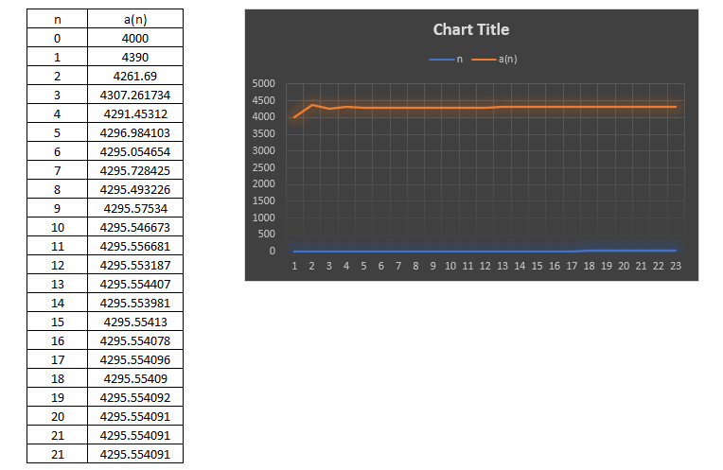

***Exercise 03:***

Mercury in Fish—Public officials are worried about the elevated levels of toxic mercury pollution in the reservoirs that provide the drinking water to your city. They have asked for your assistance in analyzing the severity of the problem. Scientists have known about the adverse effects of mercury on the health of humans for more than a century. The term mad as a hatter stem from the nineteenth-century use of mercuric nitrate in the making of felt hats. Human activities are responsible for most mercury emitted into the environment. For example, mercury, a by-product of coal, comes from the smokestack emissions of old, coal-fired power plants in the Midwest and South and is disseminated by acid rain. Its particles rise on the Dr. SIM Tepmony & Dr. LUEY Sokea Mathematical Modeling 5 Institute of Technology of Cambodia Semester I, 2022-2023 Department of Applied Mathematics and Statistics Date: 13-October, 2022 smokestack plumes and hitch a ride on prevailing winds, which often blow northeast. After colliding with mountains, the particles drop to earth. Once in the ecosystem, microorganisms in the soil and reservoir sediment break down the mercury and produce a very toxic chemical known as methyl mercury. Mercury undergoes a process known as bioaccumulation. This occurs when organisms take in contaminants more rapidly than their bodies can eliminate them. Therefore, the amount of mercury in their bodies accumulates over time. Humans can eliminate mercury from their system at a rate proportional to the amount remaining. Methyl mercury decays 50% every 65 to 75 days (known as the half-life of mercury) if no further mercury is ingested during that time. Officials in your city have collected and tested 2425 samples of largemouth bass from the reservoirs and provided the following data. All fish were contaminated. The mean value of the methyl mercury in the fish samples was 0.43µg (microgram) per gram. The average weight of the fish was 0.817 kg.

1. Assume the average adult person (70 kg) eats one fish (0.817 kg) per day. Construct a difference equation to model the accumulation of methyl mercury in the average adult. Assume the half-life is approximately 70 days. Use your model to determine the maximum amount of methyl mercury that the average adult human will accumulate in her or his lifetime.
2. You find out that there is a lethal limit to the amount of mercury in the body; it is 50 mg/kg. What is the maximum number of fish per month that can be eaten without exceeding this lethal limit?

***Solution:***

Methyl mercury in fish samples has been found up to the concentration of 0.43 $μg$ per gram and the average weight of the fish is 0.817kg

Hence the total weight of methyl mercury in a fish is:



In order to construct a different equation to model the mercury accumulation, note that the half of lifetime of Methyl Mercury is approximately 70 days (which is a period in which mercury is reduced to ½ initial amount) and an average adult consume one fish per day.

Let  be the change in the mercury concentration at end of n-th month.

Consider:



Here -0.5/70 is the factor by which remaining Methyl Mercury decomposes at the end of each day where half-life is 70 days and 351gm is the amount of daily mercury intake from fish.

***Exercise 04:***

4. Complete the modules ‘‘The Growth of Partisan Support I: Model and Estimation’’ (UMAP 304) and ‘‘The Growth of Partisan Support II: Model Analytics’’ (UMAP 305), by Carol Weitzel Kohfeld. UMAP 304 presents a simple model of political mobilization, refined to include the interaction between supporters of a particular party and recruitable non-supporters. UMAP 305 investigates the mathematical properties of the first-order quadratic-difference equation model. The model is tested using data from three U.S. counties.